
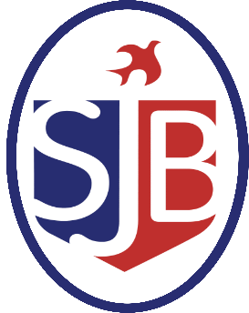
ST JOHN THE BAPTIST C of E PRIMARY SCHOOL
Level 3 EYFS Teaching Assistant commencing September 2026 – 1 year contract

St. John the Baptist is an exciting place to work, filled with inquisitive children, supported by a community of diverse families and inspiring organisations, striving to ensure all children thrive. We believe that every child should be connected to their identity, to the world around them and ready to dream bigger and reach higher. This is what drives our school and our learning.
We are seeking to appoint a committed and enthusiastic Level 3 EYFS Teaching Assistant to join our team from September 2026. The successful candidate will work under the direction of the EYFS Lead, supporting high-quality teaching and learning within the Early Years Foundation Stage. As part of this role, duties and responsibilities may change and vary as school needs dictate. This is a one-year fixed term contract.

The successful candidate will:
- Have experience developing others effectively and work well as part of an EYFS team and can consistently meet deadlines
- Have an enthusiastic, hardworking and committed approach to supporting all pupils
- Have experience in the setup of EYFS provision and have excellent organisation and time keeping skills
- Interact, supervise and keep the children safe and happy; supporting the Nursery team in the day to day running of the Nursery
- Have demonstrated consistently high-quality interactions and set up the environment across the curriculum in line with school expectations
- Be an enthusiastic model and support for the team to ensure children thrive
- Appropriate Level 3 qualification
The role will involve:
You will be expected to safeguard and support children’s wellbeing at all times and follow the Nursery policies and procedures. You will deliver activities; plan fun and engaging activities (with support from others); conduct observations/record attainment and progress of children. Daily maintenance of resources coupled with setting up engaging learning opportunities with children, is a key part of the role. As is promoting oracy development through the SCHREC approach. You will also be expected to support children with a wide range of needs.
Dietary needs (including the planning and provision of snacks) alongside supporting children with their toileting needs is part of the role.
You will also liaise and regularly communicate with parents and will be asked to take part in home visits.

Please contact Yvonne Whelan ywhelan@st-john.hackney.sch.uk to request an application pack or arrange an informal discussion.
Closing date: Friday 10th July 2026 at 12pm Interviews: WB 13/07/26 Scale: Scale 5 (£34,359 – £ 35,892 FTE)
Successful applicants will be required to apply for an enhanced Criminal Record Check via the DBS.
We are committed to safeguarding and promoting the welfare of our children and expect all members of staff to share this commitment.
St John the Baptist CE Primary School - Find us here: www.st-john.hackney.sch.uk
Primary Advantage Federation – Schools Achieving More Together

