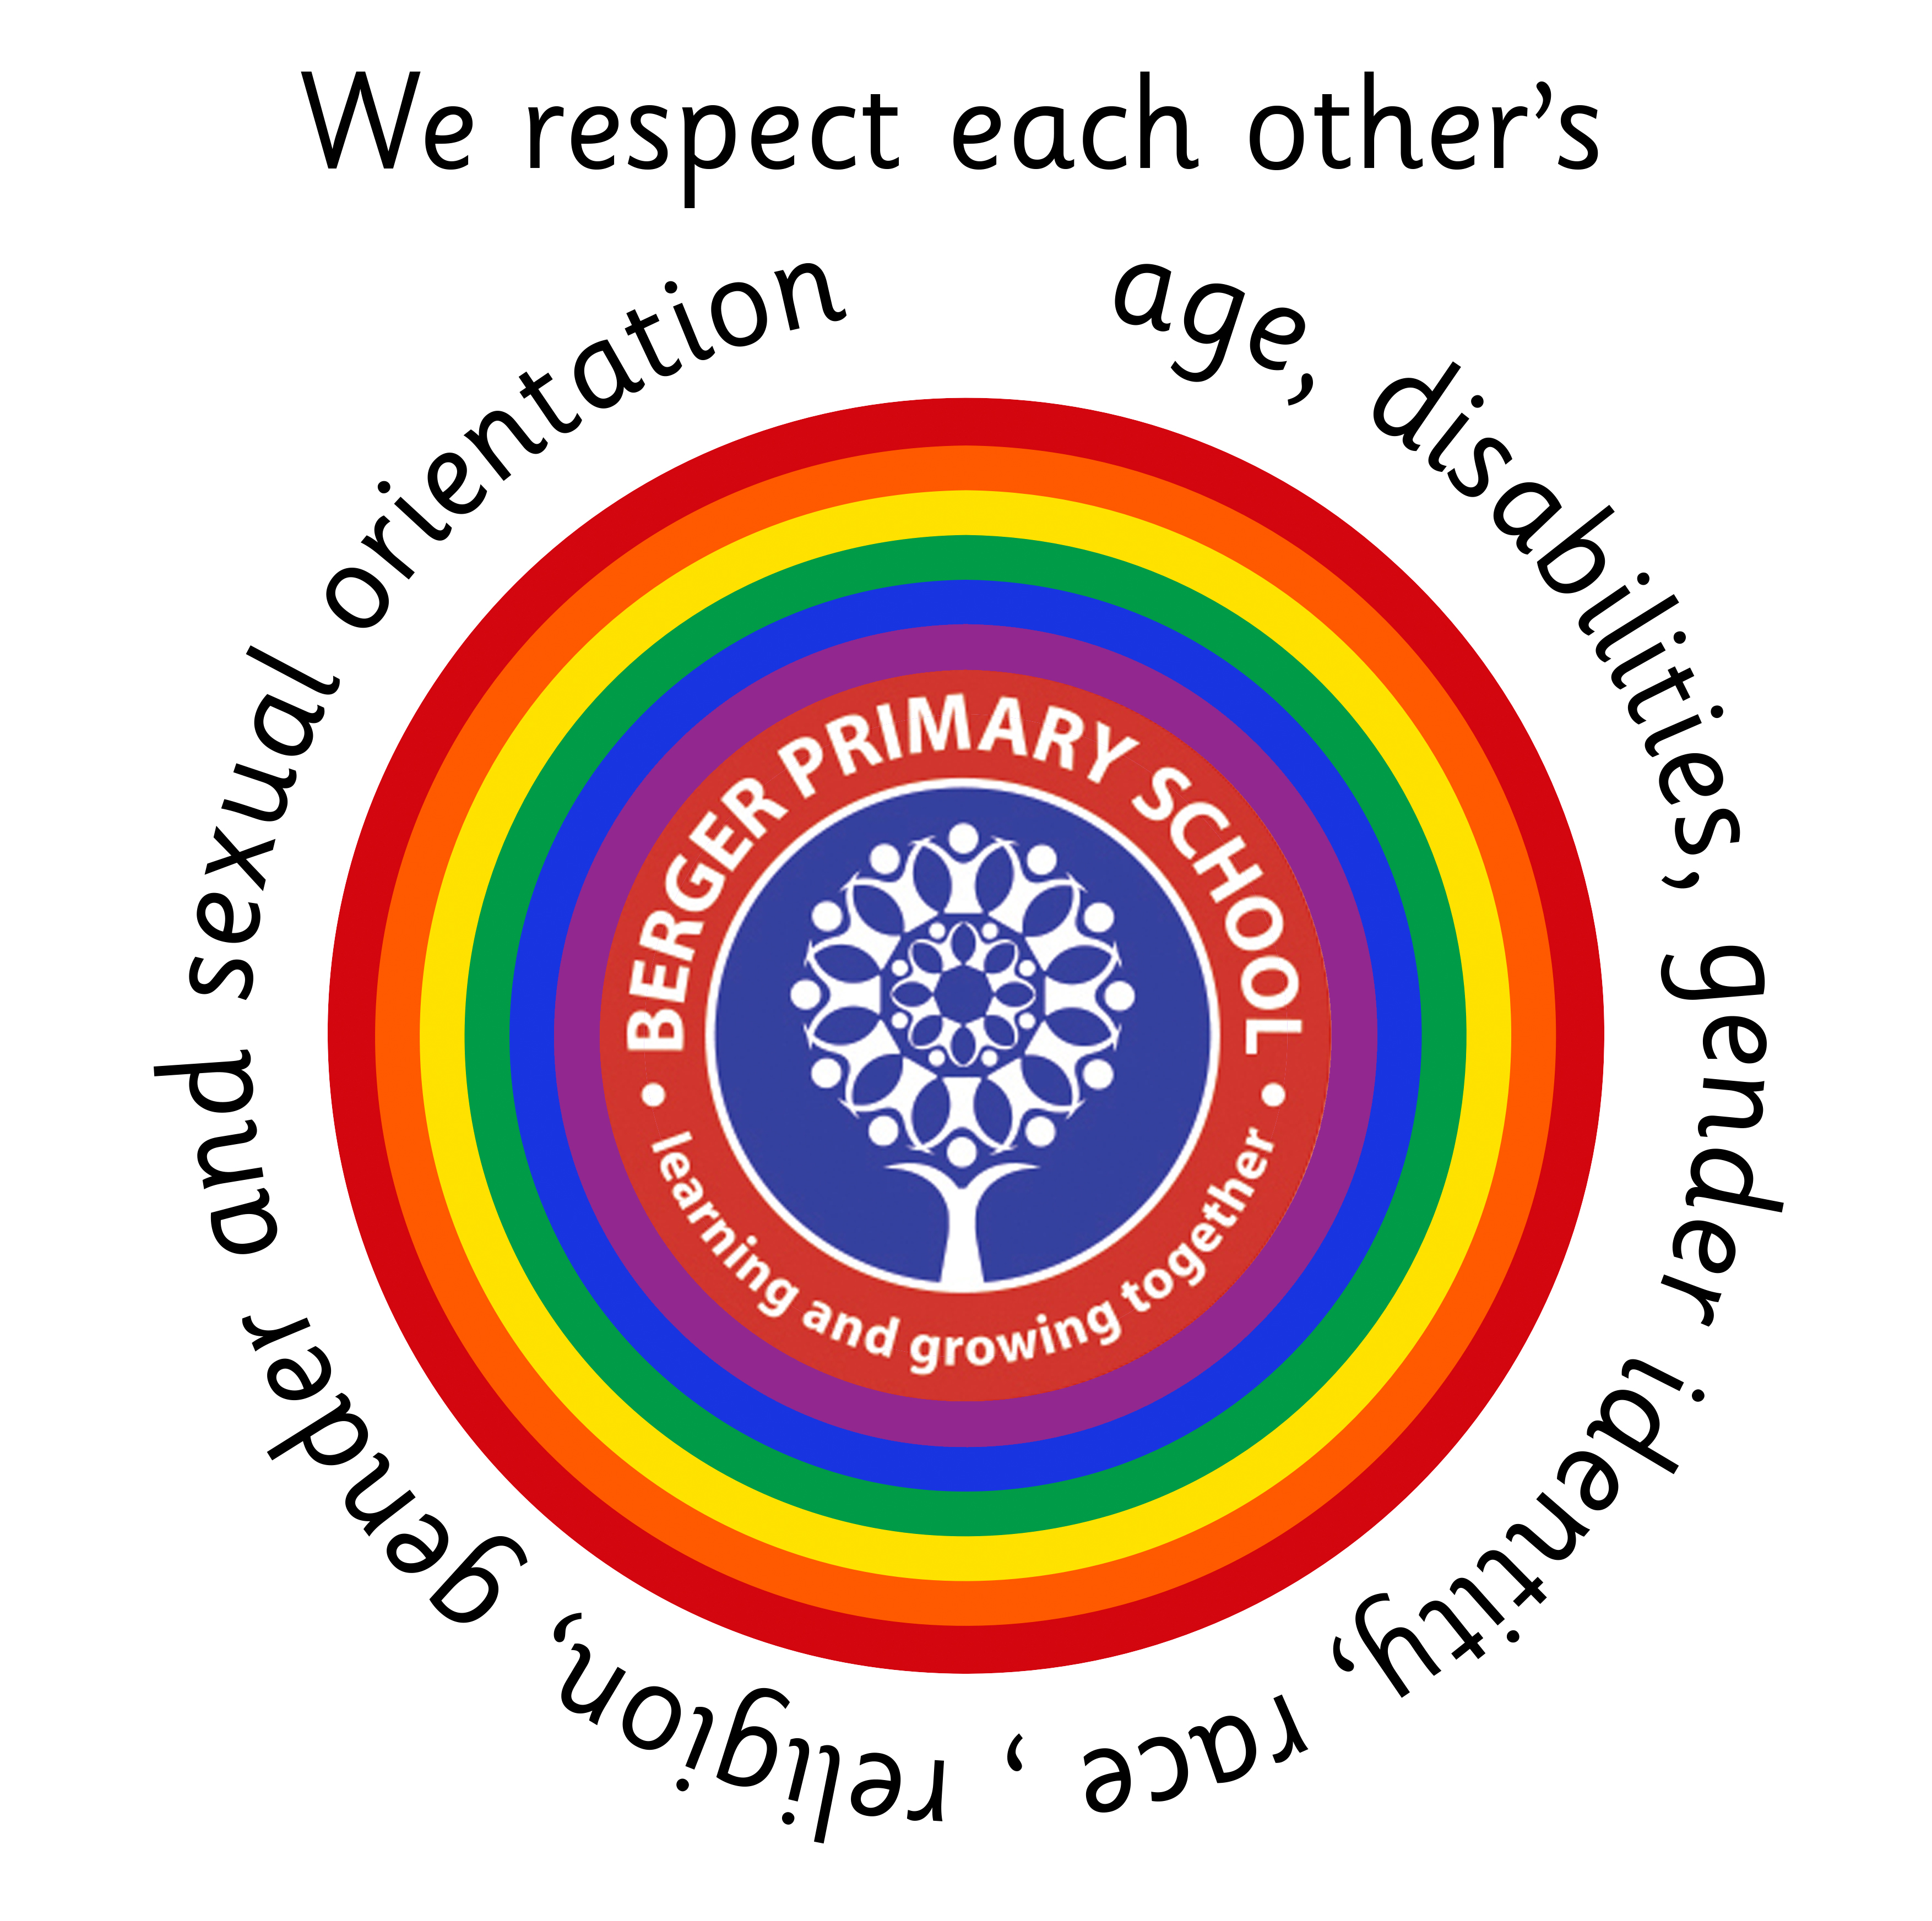
Berger Primary School

Teaching and Learning Assistant
Local Government Pay Scale 4, Term Time only
Hours: 08:30 till 15:45, 31.25 hours per week
Fixed Term Contract
Closing Date: Monday 18th September 2023
Interview Date: Tuesday 26th September 2023
Start Date: Monday 2nd October 2023
Berger Primary School seeks to appoint an enthusiastic and passionate Teaching and Learning Assistant to join our friendly team.
Berger is a vibrant and inclusive school in the heart of Hackney. In addition to achieving KS2 results higher than the national average, we are proud of our Creative Curriculum, which sees all subjects taught through the Lens of the Arts. If you are a dedicated individual, who relishes the opportunity to support children to become high-achieving, passionate and resilient learners, then we welcome your application.
Berger Primary School is committed to safeguarding and promoting the welfare of children and young people. All school posts are subject to an enhanced DBS check.
All application forms should be sent to the attention of Lovette Ryvers-Lawrence by post or via email to hr-berger@berger.hackney.sch.uk.

Address | Berger Primary School  Anderson Road, E9 6HB  Phone: 020 8985 6280

