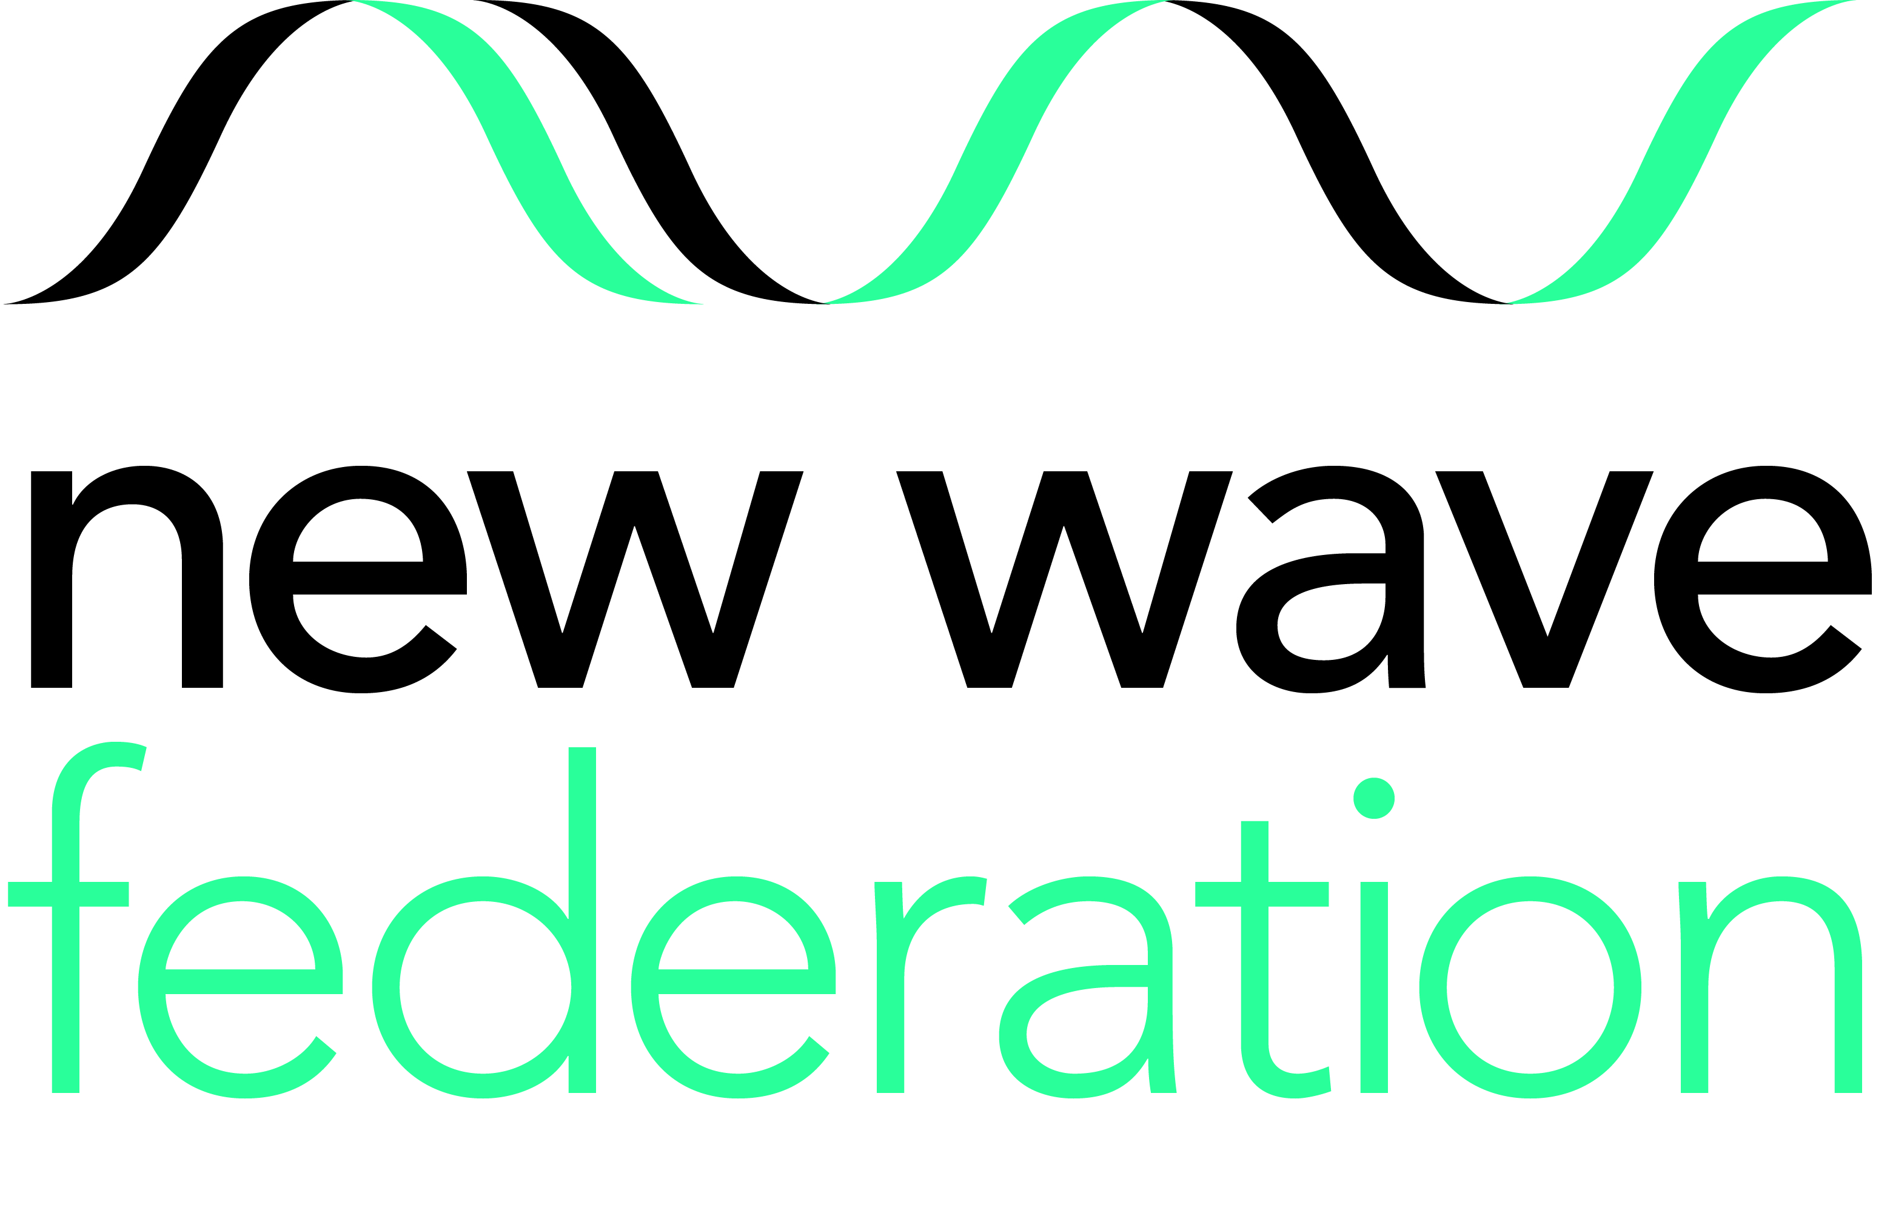

Breakfast Club Assistant
From November 2022 or earlier (Fixed Term) –November 2023
Scale 2 (point 03-04) £23,004.00- £23,421.00 pro-rata term time only
8.00am – 9.00am one hour daily
5 days a week based at Grazebrook Primary School

The New Wave Federation consists of 3 high performing and innovative primary schools in Hackney, London. In all our schools we have a passion for high standards and want all our children to achieve their potential and be inspired to go beyond that. Our school is vibrant, diverse and inclusive. There are challenges but also great rewards in the work here. If you are an effective communicator, have vision, energy and believe that every child can and will succeed, we would like to meet you. Your communication skills will enable you to build a friendly and professional relationship with staff, pupils and parent

We are looking to appoint a Breakfast Club Assistant to provide a safe, caring and stimulating environment for the pupils at Grazebrook Primary School. You will be responsible for the assistance of the daily management of the breakfast club. The school promotes healthy eating, and you will assist in encouraging pupils to maintain the schools healthy eating ethos, ensuring a high standard of cleanliness and hygiene at all times.

The role will involve setting up suitable activities, assisting in serving a daily hot breakfast, and working in partnership with parents, carers and professionals to promote the well-being of pupils. Promoting attendance at the breakfast club will be an important part of this role. This role also includes assisting in being responsible for the setting up of the club and supervision of pupils at all times, in the Breakfast Club and in the playground until they are collected by their teacher.

The role requires someone who is passionate about healthy eating and who has a rich knowledge and understanding of how to encourage this in pupils. Applicants should possess a valid Food Hygiene Certificate however training will be organised. The right person will be someone who is up to date with Food Hygiene standards, who is creative and resourceful. We want to give our pupils the very best start to the day.

HOW TO APPLY: Please download the application pack from the Hackney Education Jobs website, alternatively email: achoudhry@newwavefederation.co.uk or phone 020 8802 4051 for a pack to be sent out.
Closing date for applications: 12pm Friday 23rd September 2022
Interview date: w/c Monday 26th September 2022

GRAZEBROOK PRIMARY SCHOOL WOODBERRY DOWN COMMUNITY PRIMARY SCHOOL
Lordship Road Woodberry Grove
London N16 0QP London N4 1SY
0208 802 4051 020 8800 5758
www.grazebrook.hackney.sch.uk www.woodberrydown.hackney.sch.uk

SHACKLEWELL PRIMARY SCHOOL
Shacklewell Row
London E8 2EA
Phone: 0207 254 1415
www.shacklewell.hackney.sch.uk

The New Wave Federation of schools is committed to safeguarding and promoting the welfare of children and young people. All posts are subject to an enhanced DBS check. We welcome applications from all sections of the community, regardless of gender, race, religion, disability, sexual orientation or age.

