


Harrington Hill Primary School
Address: Mount Pleasant Lane, London E5 9JG | Telephone: 0208 806 7275
Email: admin@harringtonhill.hackney.sch.uk | Website: www.harringtonhill.hackney.sch.uk
We are looking for an…
Scale 5 Early Years Educator Level 2
All year round, flexible shift work, 36 hours per week
Full time. Start date: 1st September 2025
We are looking to recruit 2 upbeat (happy and smiling!), innovative, creative and dynamic early years practitioners as Scale 5 Early Years Educators to join this stable, reflective and dedicated team. The post will be based at Oldhill Children’s Centre Nursery.
As an Early Years Practitioner you will need to be able to rigorously plan, prepare and deliver activities for the diverse needs of the children. You need to have the ability to monitor, assess, record and produce written reports as an expectation, taking responsibility for key children’s learning and development. Excellent literacy skills and communication is required and the ability to relate well with others in a team and relate well to babies from 6 months up.
The posts are to start by September 2025 for a permanent position subject to a three / five-month probation review.
The Early Years Practitioner will be required to work flexibly taking direction from the Room Leader, Senior, Deputy’s and Head Teacher.
Candidates must be able to carry out and write up necessary observations to inform and evaluate the child’s needs. They must have proven experience and be willing to come in and lead an activity as part of the interview process.
Candidates must be able to use their own initiative and have a good standard of written English. We are able to offer a friendly, supportive staff with great professional development and career opportunities.
Candidates are required to have a level 3 qualification in early years and childcare for the scale 5 role. You will be required to work flexible hours as the day care operates a shift system all year round.
For more information, please contact the School Business Manager on 0208 806 7275 Application forms and further details are available online. Supporting statements should indicate your previous experience. Please email completed application forms to adedominicis@harringtonhill.hackney.sch.uk
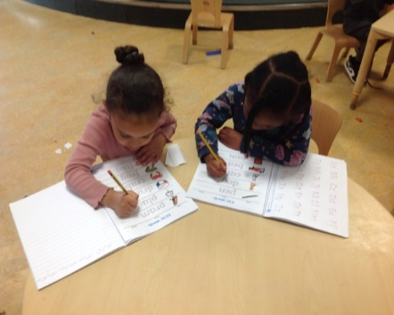
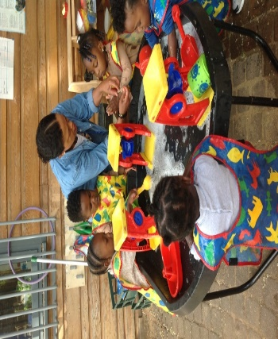
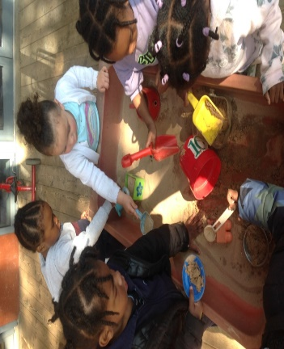
https://harringtonhill.hackney.sch.uk

We are committed to safeguarding and promoting the welfare of our children and expect all members of staff to share this commitment. This post is subject to an Enhanced Disclosure Application to the Disclosure and Barring Service. We welcome applications from all sections of the community regardless of gender, race, religion, disability, sexual orientation or age.
Closing date for applications: Friday 27th June 2025 at 12pm. Interview: Wednesday 2nd July 2025

