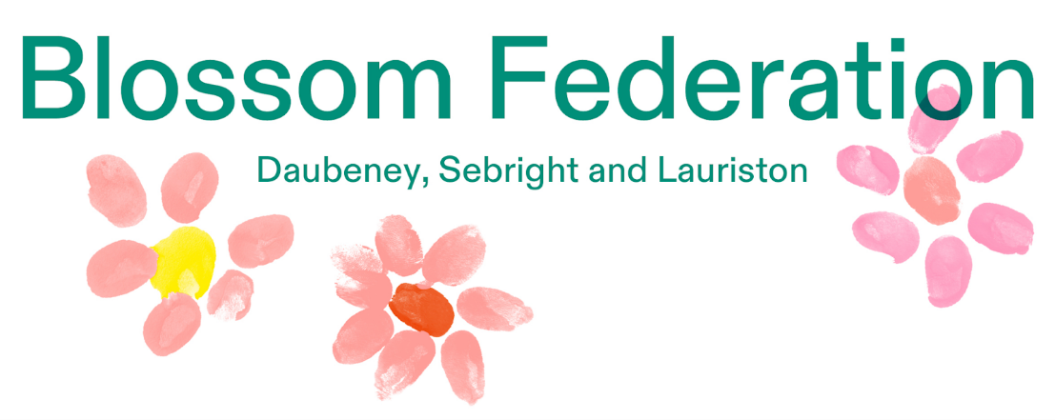

Class Teacher Vacancy

Recruitment Pack



Thank you for your interest in the role of Class Teacher at Lauriston Primary School

Where learning adventures begin

Lauriston is part of the Blossom Federation which is made up of Daubeney, Sebright & Lauriston Primary Schools, Sebright Children’s Centre and Daubeney Children & Family Hub. Collectively, we serve over 1,200 Hackney children and families and are proud of our provision in supporting their education and development. We want to prepare children for a successful future in the real world. It is our aim to provide our children with a broad and exciting curriculum which gives them the skills, knowledge and learning to be prepared for their life ahead.
Children's early experiences are hugely important in forming a person. We want our children to:
- enjoy and show a curiosity to learn
- to feel safe and secure in an environment which is high quality and well resourced
- to have a high regard for staff and children's mental health and wellbeing
- to reach their potential across the core areas and receive the support they need to achieve well
- develop a range of skills and have experiences which mean they are confident and ready for the future
- feel celebrated for their achievements
- to appreciate diversity, difference and have strong global awareness as well as understanding of the school community

We aim to:
- Provide good quality teaching experiences from committed and enthusiastic staff
- Inspire those we teach through creative, exciting and memorable learning experiences
- Enable children to reach their full potential in a rich and inclusive learning environment in which they feel secure, valued and encouraged
- Give children a love of learning and the confidence to express themselves
- Instill respect, good manners, empathy and care in our children
- Develop thoughtful and caring children who form their own views and who are proud of their school
- Encourage children to respect and value our rich and diverse communities and in the world around them

Thank you for your interest in this vacancy.
I hope that you will find this information pack helpful.
If you would like to learn more about our Federation, we would be delighted to answer any questions you may have. Our contact details are in this pack, and we can offer tours of all three school sites so you can meet our children and staff and see first-hand what we do. Our school websites also offer a lot of information about our staff, curriculum and the way that we work.
Daubeney, Sebright & Lauriston Schools are in the vibrant and diverse community of Hackney, East London with easy transport links into and out of Central London.
Daubeney & Sebright have been in partnership since January 2014 with Lauriston joining us in 2018. We have a joint Governing Board and strong links to our Local Authority. Each school has its own Head of School and Senior Leadership Team who work together with the common aim of giving children the very best.
We are looking to recruit staff who are looking to further develop their teaching skills and professional talents. We are looking for practitioners who are confident, self-reflective and who have the energy and skill to make the difference that our children deserve.
If you are hardworking, reflective, resilient and looking for a new challenge or somewhere to start your teaching career then we would love to hear from you.
I look forward to meeting you

Robin Warren
Executive Head Teacher

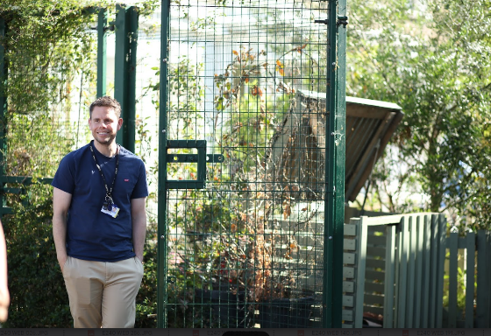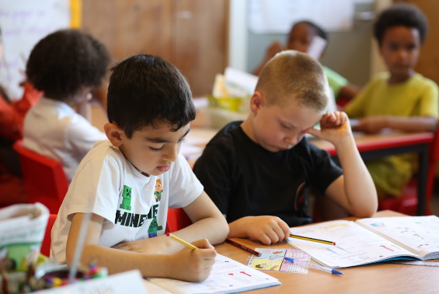

Class Teacher Position Available
Lauriston Primary School
Required for April 2026
Mains Scale / Upper Pay Scale
Permanent Contract

We are looking for a dedicated and enthusiastic class teacher to join our teaching teams at Lauriston Primary School. We are excited to bring some new talent into our teaching teams to join the Blossom Federation at a very exciting point in our development. Check out this video all about us.

Lauriston can offer you
- A welcoming, friendly and talented staff team with opportunity to work with an experienced peer teacher
- A commitment to high standards and a drive for excellence
- Happy, responsive, well-behaved children who enjoy learning
- Excellent professional development opportunities and support in leading outstanding teaching and learning
- High quality support and CPD

You will:
- Have teaching experience in a London School
- Have a commitment to inclusion and for all children to achieve their best
- Be able to motivate and inspire
- Know about what makes the Blossom Federation and Lauriston School special
- Be committed to ensuring all children succeed and develop their potential
- Be creative, flexible and passionate about learning
- Be organised and hard working but realistic about balancing work and real life.
How to apply
- Read the job description and person specification carefully.
- Complete the application form either electronically or print it off and hand write it.
- Ensure your supporting statement relates to the competencies outlined in the person specification.
- Email your competed application to
Louise Corkrey admin@lauriston.hackney.sch.uk or send by post:
Recruitment c/o Lauriston Primary School, Rutland, London E9 7JS

Closing Date: Thursday 29th January 2026 at 12 noon
Interviews: Week of 2nd February 2026

Our schools are committed to safeguarding and promoting the welfare of children and young people and expect all staff and volunteers to share this commitment.

Successful candidates will be required to complete an enhanced DBS disclosure.

We welcome applications from all sections of the community, regardless of gender, race, religion, disability, sexual orientation or age.

If you have queries or want to visit our schools, contact the person above.

We look forward to receiving your application!



Person Specification: Class Teacher

 | Essential | Desirable
Qualifications | Qualified Teacher status | Evidence of continuous INSET and commitment to further professional development
Experience | The Class Teacher should have experience of:  teaching or teaching practice at Key Stage EYFS/KS1 or KS2. | In addition, the Class Teacher might have experience of:  teaching across the whole Primary age range;  working in partnership with parents.
Knowledge and understanding | The Class Teacher should have knowledge and understanding of:  the theory and practice of providing effectively for the individual needs of all children (e.g. classroom organisation and learning strategies);  statutory National Curriculum requirements at the appropriate key stage;  the monitoring, assessment, recording and reporting of pupils’ progress;  the statutory requirements of legislation concerning Equal Opportunities, Health & Safety, SEN and Child Protection;  the positive links necessary within school and with all its stakeholders;  effective teaching and learning styles. | In addition, the Class Teacher might also have knowledge and understanding of:  the preparation and administration of statutory National Curriculum tests;  the links between schools, especially partner schools.
Skills | The Class Teacher will be able to:  promote the school’s aims positively, and use effective strategies to monitor motivation and morale;  develop good personal relationships within a team;  establish and develop close relationships with parents, governors and the community;  communicate effectively (both orally and in writing) to a variety of audiences;  create a happy, challenging and effective learning environment. | In addition, the Class Teacher might also be able to:  develop strategies for creating community links.
Personal characteristics | Approachable  Committed  Enthusiastic  Able to motivate self and others  Calm under pressure  Well-organised



Job Description
Class Teacher

The appointment is subject to the current conditions of employment for Class Teachers contained in the School Teachers' Pay and Conditions Document, the 1998 School Standards and Framework Act, the required standards for Qualified Teacher Status and Class Teachers and other current legislation.

This job description may be amended at any time following discussion between the head teacher and member of staff and will be reviewed annually.

Areas of Responsibility and Key Tasks
a) Planning, Teaching and Class Management

To teach allocated pupils by planning their teaching to achieve progression of learning through:
- Identifying clear teaching objectives and specifying how they will be taught and assessed;
- Setting tasks which challenge pupils and ensure high levels of interest;
- Setting clear targets, building on prior attainment
- Identifying SEND or very able pupils and meeting their learning needs;
- Make effective use of teacher assessment, including assessment for learning, to inform planning and ensure coverage of programmes of study;
- Ensure effective teaching and best use of available time;
- Monitor and intervene to ensure sound learning and discipline;
- Use a variety of teaching methods to: match approach to content, structure information, present a set of key ideas and use appropriate vocabulary, use effective questioning, listen carefully to pupils, give attention to errors and misconceptions, select appropriate learning resources and develop study skills through library, I.C.T. and other sources;
- Ensure pupils acquire and consolidate knowledge, skills and understanding appropriate to the subject taught;
- Evaluate their own teaching critically to improve effectiveness.

Additional Standards for Nursery and Early Years

- Take account of pupils’ needs by providing structures learning opportunities which develop the areas of learning identified in national and local policies and particularly the foundations for literacy and numeracy;
- Encourage pupils to think and talk about their learning, develop self-control and independence, concentrate and persevere, and listen attentively;
- Use a variety of teaching strategies which involve planned adult intervention first-hand experience and play and talk as a vehicle for learning;
- Effectively manage parents and other adults in the classroom.
b) Monitoring, Assessment, Recording, Reporting; to:

- Assess how well learning objectives have been achieved and use them to improve specific aspects of teaching;
- Mark work promptly following the school’s marking policy;
- Monitor pupils' work and set appropriate targets for progress;
- Use teacher assessment to assess and track pupils' progress
- Meet all assessment deadlines for teacher assessments
- Keep records to check work is understood and completed;
- Monitor strengths and areas for development through AfL to inform planning and recognise the level at which the pupil is achieving;
- Prepare and present informative reports to parents.

c) Other Professional Requirements; to:
- Have a working knowledge of teachers' professional duties and legal liabilities;
- Operate at all times within the stated policies and practices of the school;
- Establish effective working relationships and set a good example through their presentation and personal and professional conduct;
- Endeavour to give every child the opportunity to meet high expectations and achieve at their highest level;
- Contribute to the corporate life of the school through effective participation in meetings and management systems necessary to coordinate the management of the school:
- Take responsibility for their own professional development and duties in relation to school policies and practices;
- Liaise effectively with parents and governors;
- Take on any additional responsibilities which might from time to time be determined by the Head of School

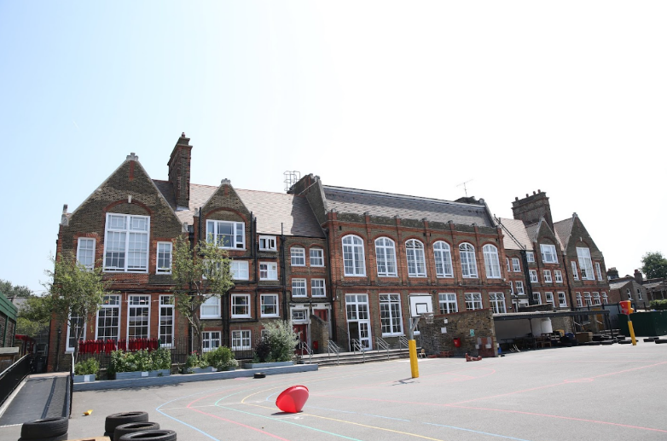

We look forward to working with you



