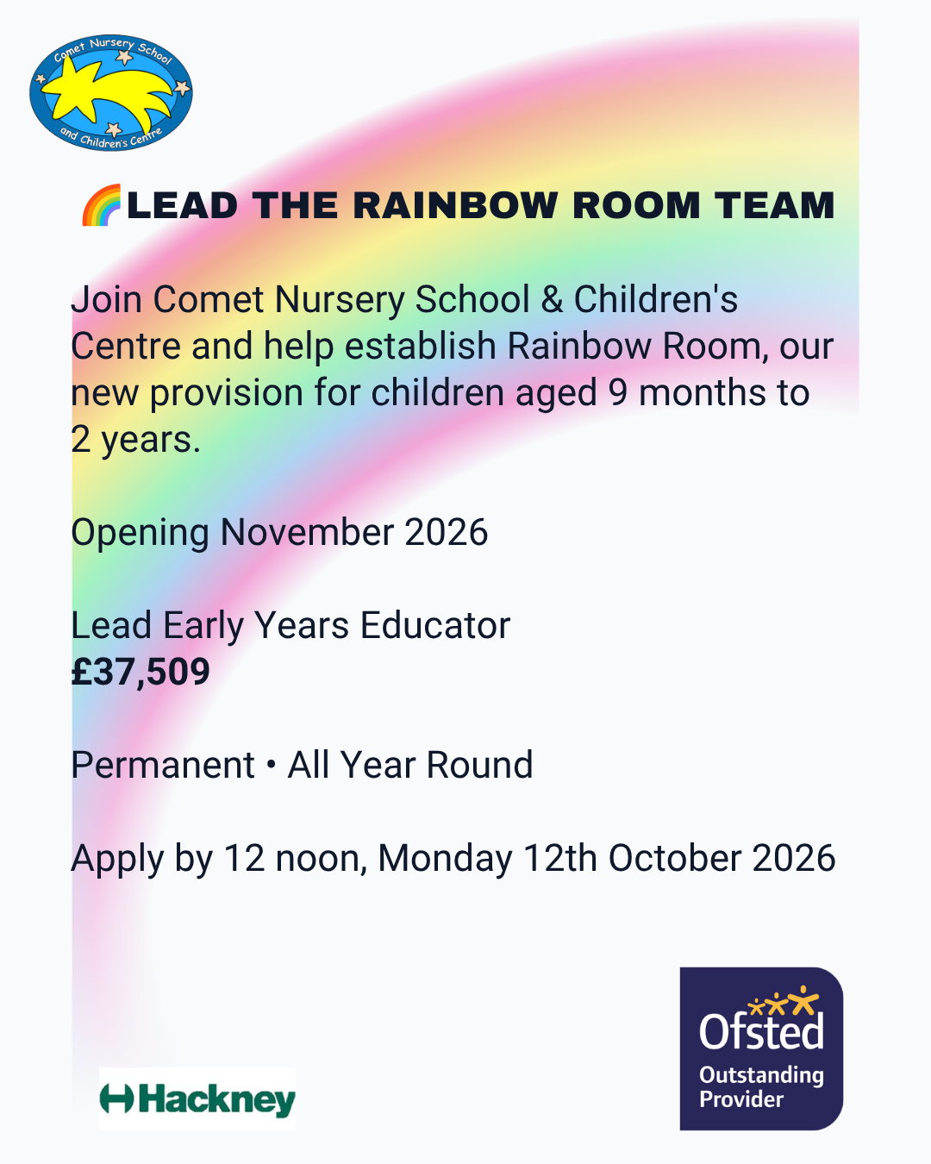

Welcome to Comet
Dear Applicant,
Thank you for your interest in joining Comet Nursery School and Children's Centre.
Comet is a vibrant maintained nursery school and Children's Centre in the heart of Hoxton. We are proud of our reputation for providing high-quality early education, our commitment to inclusion, and the strong relationships we build with children, families and the wider community.
At Comet, we believe every child deserves the very best start in life. Our approach is rooted in a deep understanding of early childhood development, where children are supported to become curious, creative and confident learners through rich, play-based experiences. We are ambitious for every child and strive to provide an environment where all children can thrive and achieve their full potential.
Inclusion is at the heart of everything we do. Alongside our nursery and two-year-old provision, we are proud to host Hackney's first maintained nursery school Additional Resource Provision, providing specialist support for children with special educational needs. Our experienced team works closely with families and professionals to ensure every child receives the support they need to succeed.
This year marks an exciting new chapter as we expand our provision to include children from 9 months old. Our new baby room, Rainbow Room, will offer high-quality early education and care for our youngest children, providing families with continuity of support from the earliest stages of their child's learning journey.
As a Gold Rights Respecting School, we are committed to ensuring that children feel safe, valued and respected, while placing learning, development and wellbeing at the heart of everything we do.
We are looking for enthusiastic, reflective and caring professionals who share our passion for early years education, inclusion and family partnership working. In return, you will join a supportive team that is committed to continuous improvement and making a difference for children and families.
I hope this gives you a flavour of life at Comet and the exciting opportunities ahead.
Best wishes,
Lisa Clarke
Headteacher

At Comet, we are proud to offer:
- A welcoming, inclusive and diverse school and Children's Centre community where every child, family and member of staff is valued.
- The opportunity to work in an innovative maintained nursery school, including our new baby room provision and Hackney's first maintained nursery school Additional Resource Provision (ARP).
- A strong commitment to staff wellbeing, including a focus on manageable workloads and a healthy work-life balance.
- High-quality professional development, training and career progression opportunities.
- Opportunities to visit and learn from outstanding early years settings and professionals.
- A reflective and collaborative team culture where ideas, creativity and professional dialogue are encouraged.
- The chance to contribute to whole-school development projects and develop areas of specialist expertise.
- Supportive leadership that values and invests in its staff.
- Priority nursery places for staff children, subject to availability.
- Priority access to breakfast and after-school club places for staff children attending Comet.

We are looking for someone who:
- Is passionate about early childhood education and making a difference to the lives of young children and their families.
- Has experience of working with children under five and understands how young children learn and develop.
- Can create stimulating, engaging learning environments both indoors and outdoors.
- Has high expectations for all children and is committed to helping every child achieve their full potential.
- Shares our commitment to inclusion and has the ability to build positive relationships with children from diverse backgrounds and with a range of needs.
- Recognises parents and carers as children's first educators and values strong partnership working with families.
- Has excellent communication, literacy, numeracy and ICT skills.
- Is reflective, enthusiastic and keen to continue developing their professional practice.
- Works effectively as part of a team and contributes positively to the wider life of the school and Children's Centre.
- Shares Comet's values of learning, inclusion, respect and community.

Job Description for Lead Early Years Educator (Rainbow Room)

Job title: Lead Early Years Educator (Rainbow Room)
Reporting to: Head Teacher
Grade: Scale 6 pt.18 (£37,509)
Hours: 36 hours per week, all year round
Contract: Permanent

Purpose of the post:
To lead the delivery of high-quality early education and care for children aged 9 months to 2 years within Rainbow Room. The post holder will provide professional leadership within the room, ensuring high standards of teaching, learning, care and safeguarding whilst supporting the development of colleagues and maintaining strong partnerships with families.
The Lead Early Years Educator will work closely with the Headteacher to establish and develop Rainbow Room, ensuring that the provision reflects Comet's commitment to high-quality early education, inclusion and continuous improvement.

Key Responsibilities

Leadership and Quality of Provision
- Lead the day-to-day organisation and running of Rainbow Room.
- Promote high expectations for teaching, learning and care across the provision.
- Support the implementation and development of an ambitious curriculum for children aged 9 months to 2 years.
- Monitor the quality of provision, learning environments and children's experiences, identifying areas for improvement.
- Lead by example through excellent early years practice.
- Support the induction, mentoring and development of Early Years Educators, apprentices and students.
- Contribute to self-evaluation, development planning and quality improvement across the school.
- Work closely with the Headteacher to establish policies, procedures and routines for the baby room provision.

Supporting Learning and Development
- Lead curriculum planning within Rainbow Room, ensuring learning experiences are ambitious, engaging and responsive to children's interests and development.
- Support colleagues in planning for children's next steps and monitoring progress.
- Deliver high-quality teaching and learning experiences appropriate to the developmental needs of babies and toddlers.
- Oversee the implementation and evaluation of a broad, balanced and ambitious curriculum in line with the Early Years Foundation Stage.
- Observe, assess and record children's learning and development, using this information to plan next steps and support progress.
- Create enabling indoor and outdoor learning environments that promote curiosity, exploration, creativity and independent learning.
- Support children's communication, thinking, confidence and independence through high-quality interactions and learning experiences.
- Work collaboratively with colleagues to ensure all children make good progress from their starting points.
- Support children with SEND and those learning English as an Additional Language through inclusive, personalised approaches.

Building Relationships and Supporting Children's Wellbeing
- Develop warm, secure and respectful relationships with children.
- Follow children's individual care routines and respond to their needs sensitively.
- Promote emotional wellbeing and support children to develop secure attachments.
- Encourage positive behaviour through respectful interactions and positive role modelling.
- Celebrate diversity and ensure all children feel valued, respected and represented within the provision.
- Promote communication and language development through responsive interactions, songs, stories and conversations.

Key Person Responsibilities
- Act as Key Person for an allocated group of children.
- Support home visits, settling-in sessions and transition arrangements.
- Monitor the quality and consistency of observations, developmental records and children's special books across Rainbow Room.
- Maintain accurate observations, developmental records and children's special books in accordance with school procedures.
- Monitor children's progress and identify next steps in learning.
- Build positive and professional relationships with parents and carers, recognising them as children's first educators.
- Be the first point of contact for allocated families.
- Work collaboratively with external professionals and contribute to support plans and review meetings for children with additional needs.

Inclusion and Family Partnership Working
- Promote an inclusive environment where all children and families feel welcomed, valued and respected.
- Ensure learning opportunities reflect and celebrate the diversity of the school community.
- Support children to express their views and interests in ways appropriate to their age and stage of development.
- Work collaboratively with colleagues, families and external professionals to support children's participation, learning and wellbeing
- Support colleagues to build effective partnerships with families.
- Contribute to meetings with parents and carers where additional support or guidance is required.
- Model inclusive practice and support colleagues in meeting the needs of all children.

Safeguarding, Health, Safety and Welfare
- Promote and safeguard the welfare of all children at all times.
- Maintain high standards of hygiene, health and safety throughout the provision.
- Attend to the needs of children who are unwell or injured, administering First Aid where appropriate, completing accident records and ensuring children receive appropriate care until collected.
- Follow all safeguarding and child protection procedures and report any concerns immediately to the Designated Safeguarding Lead (DSL).
- Contribute to maintaining a safe, secure and healthy environment for children.

Providing Personal Care and Meeting Children's Individual Needs
- Support children with personal care routines, including nappy changing, toileting, dressing and undressing, in a respectful and sensitive manner.
- Support feeding and mealtime routines, including bottle feeding and assisting children who require additional support with eating and drinking.
- Follow agreed sleep and rest procedures for younger children.
- Support children's physical development and independence, using appropriate moving and handling techniques where required.
- Ensure all care routines promote children's dignity, wellbeing and independence whilst meeting their individual needs.

Supporting and Developing Colleagues
- Provide day-to-day guidance and support to Early Years Educators and support staff within Rainbow Room.
- Support the induction, mentoring and development of new staff, apprentices and students.
- Share good practice and contribute to a culture of reflection, collaboration and continuous improvement.
- Work collaboratively with colleagues across the school to promote high-quality early years practice.

Professional Development
- Participate fully in training, supervision, appraisal and professional development opportunities.
- Keep up to date with developments in early years education, safeguarding and child development.
- Reflect on and continually develop own practice.

General Responsibilities
- Carry out duties in accordance with school policies, local authority requirements and relevant legislation.
- Promote equality, diversity and inclusion in all aspects of the role.
- Maintain confidentiality in relation to children, families, staff and school matters.
- Work in accordance with Comet's ethos, values and Rights Respecting School principles.
- Work flexibly and collaboratively as part of the wider school and Children's Centre team.
- Undertake other duties appropriate to the grade and responsibilities of the post as reasonably determined by the Headteacher.
- Contribute positively to the wider life and development of Comet Nursery School and Children's Centre.

Person specification
criteria | Essential | Desirable
Qualifications  and training | - Full and relevant Level 3 Early Years qualification.  - Evidence of continuing professional development. | - Early Years Lead Practitioner, Foundation Degree or equivalent higher qualification.  - Paediatric First Aid qualification  - Food Hygiene qualification
Experience | - Significant experience of working with children aged 0-2 years  - Experience of supporting children's learning and development within the EYFS  - Experience of leading practice within an early years environment.  - Experience of supporting or mentoring colleagues, students or apprentices.  - Experience of planning, monitoring and evaluating provision for young children.  - Experience of working in partnership with parents and carers  - Experience of creating engaging learning environments indoors and outdoors | - Experience of working in a high-quality early years setting.  - Experience of supporting children with a range of learning and developmental needs.
Knowledge and Understanding | - Understanding of what constitutes high-quality teaching and learning in the early years.  - Understanding of effective curriculum planning, assessment and quality improvement.  - Good knowledge of the Early Years Foundation Stage  - Understanding of child development and how young children learn through play and relationships  - Understanding of safeguarding and child protection responsibilities  - Understanding of inclusive practice and meeting the needs of diverse learners  - Understanding of the importance of family partnership working
Skills and Abilities | - Ability to lead and motivate others through positive professional role modelling.  - Ability to coach, mentor and support colleagues.  - Ability to organise and prioritise the day-to-day running of a room.  - Ability to build positive relationships with children, families and colleagues  - Strong observation, assessment and record-keeping skills  - Excellent communication and interpersonal skills  - Good literacy, numeracy and ICT skills  - Ability to work effectively as part of a team
Personal qualities | - Passionate about early years education and achieving the best outcomes for children  - Warm, nurturing and responsive practitioner  - Committed to inclusion, equality and anti-discriminatory practice  - Demonstrates initiative and professional leadership.  - Commitment to maintaining high standards and driving continuous improvement.  - Reflective and committed to professional development  - Flexible, positive and able to contribute to the wider life of the school and Children's Centre

Notes:
This job description may be amended at any time in consultation with the postholder.

