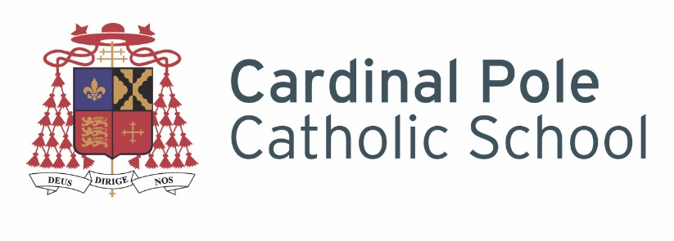

Cardinal Pole Catholic School is a successful, oversubscribed school in Hackney, with a good OFSTED and graded Outstanding for progress post 16. We are a vibrant community based in a new building.. We are looking to recruit staff keen to support the school on its journey to outstanding.
The school is on good local bus routes, and is a few minutes’ walk from London Overground stations at Hackney Central and Homerton.

Exam and Data Manager
Grade: PO2 (opportunity for P03 for a suitable candidate)
Hours: 35 hrs per week, 52 Weeks a Year
Closing Date for applicants: 8am on Friday 11th June 2021
Interview Date: TBC
Start Date: ASAP

The Governing Body is looking to appoint an exceptional Exam and Data Manager
In order to be considered for this contract it is essential you hold experience of working within a school based data position using SIMS – you will need to be highly numerate and able to use spreadsheets in order to manipulate data.

Please send your completed application, recruitment monitoring and rehabilitation of offenders act forms to staceywright@cardinalpole.co.uk

Please note that CVs will not be accepted.

Cardinal Pole Catholic School is committed to safeguarding and promoting the welfare of children and young people and expect all staff and volunteers to share this commitment. An enhanced DBS check will be undertaken.
We are an Equal Opportunities employer with excellent professional development opportunities.

Professional Development:
We can offer you professional development to begin or advance your career. You will be part of a school that is established in developing practitioners and nurturing future leaders. The opportunities for progression at Cardinal Pole are significant. We offer a range of CPD, including multiple Middle Leadership pathways in addition to supporting preparation for Senior Leadership via MA study, NPQSL and SLT secondment opportunities. There is no doubt that these opportunities will help you achieve your own career ambitions rapidly.
Why work at Cardinal Pole?
Cardinal Pole is a unique school and an educating community. As a Catholic school, the success our students has been achieved with a different philosophy to many other inner city schools. Come and see it for yourself. We aim for our school to be a challenging but humane community, where we seek to ensure that everyone is treated with dignity and respect. We also make sure all of our students pursue a rich programme of study at all key stages appropriate for their age and ability, ensuring that there is no narrowing of the curriculum.
These aims, coupled with high expectations for everyone has resulted in remarkable success for our students.
- Academic results that places the school in the top 10% of all schools in the country for progress at GCSE. (Current Progress 8 Score +0.41 (FFT).
- A-Level and Vocational results that place the Sixth Form in the Top 2% nationally for progress (ALPs outstanding over last 3 years)

Benefits:
- An incredible team of staff who are highly skilled, dynamic and passionate about securing the very best outcomes for the community we serve.
- Excellent CPD opportunities at all levels including part-funded and fully funded MA study (T&Cs apply)
- A sensible marking policy, with protected time for marking.
- Maximum of 80% teaching timetable to facilitate marking, planning and meeting times (more planning time for NQT’s)
- Centralised detention system for behaviour, punctuality and homework to ensure teachers are as free as possible to focus on teaching, planning and marking.
- Sophisticated modern school building set in the heart of vibrant Hackney
- Free staff access to a modern and high quality gym
- A proactive and thriving staff well-being group
- Free Breakfast Club every day for staff and students
- Free Bike servicing for staff and the option of joining the Cycle to Work scheme
- Travel Loans. Interest free loans to assist staff in meeting travel costs (T&Cs apply)

