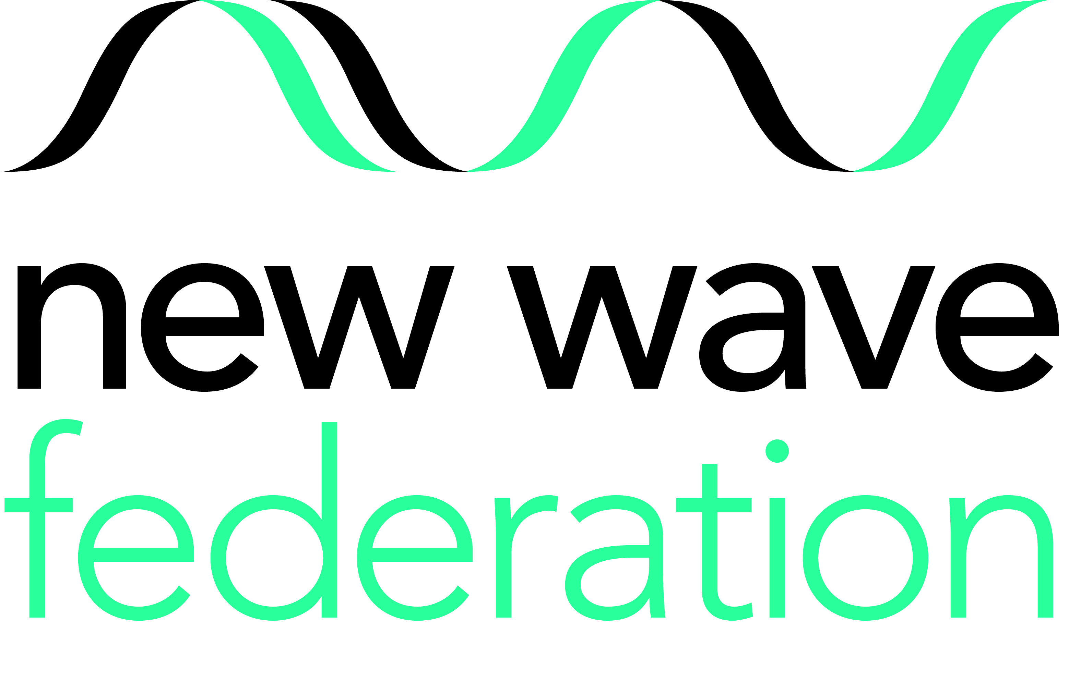

Catering Manager
From October 2021 or earlier (Permanent)
Scale 5 (point 12-15) £26,544.00 - £28,005.00 pro-rata term time only
7.30am – 3.45pm 5 days a week based at Grazebrook Primary School

The New Wave Federation consists of 3 high performing and innovative primary schools in Hackney, London. In all our schools we have a passion for high standards and want all our children to achieve their potential and be inspired to go beyond that. Ashlyns Organics provide in house catering at the school and we provide an exceptional Catering Operations Manager for you to work alongside. The school meals are innovative and creative and the right person will be able to ensure that this level of excellence in catering continues. The right person will be someone who is up to date with 21st century catering. We can offer you a 5* catering environment with exceptional kitchen facilities and equipment.

The role requires someone who is dynamic and passionate about school meal catering & service and has a rich knowledge and understanding of food & nutrition. Previous experience of working as a Catering Manager /Chef in a school is desirable. Our parents and carers want the very best school meals service for their children and so do we. The role requires someone who has the following:

- City & Guilds NVQ Level 3 in Catering or NVQ Level 2
- Basic Food Hygiene Certificate
- Proven ability to work on own initiative
- Experience in managing groups of staff, on-job-training
- Good organisational and communicational skills
- Ability to order and maintain stock controls
- Ability to carry out clerical duties
- Good Knowledge of Health and Safety/ Food Hygiene practice
- Knowledge of nutritional standards for school meals
- Experience in hospitality and functions
- Good computing skills

Our school is vibrant, diverse and inclusive. There are challenges but also great rewards in the work here. If you are an effective communicator, have vision, energy and believe that every child can and will succeed, we would like to meet you. Your communication skills will enable you to build a friendly and professional relationship with staff, pupils and parents. Previous applicants need not apply.

HOW TO APPLY: Please download the application pack from the Hackney Learning Trust website, alternatively email: achoudhry@newwavefederation.co.uk or phone 020 7254 1415 for a pack to be sent out.
Closing date for applications: 12pm Friday 24th September 2021
Interview date: w/c Monday 4th October 2021

GRAZEBROOK PRIMARY SCHOOL WOODBERRY DOWN COMMUNITY PRIMARY SCHOOL
Lordship Road Woodberry Grove
London N16 0QP London N4 1SY
0208 802 4051 020 8800 5758
www.grazebrook.hackney.sch.uk www.woodberrydown.hackney.sch.uk

SHACKLEWELL PRIMARY SCHOOL
Shacklewell Row
London E8 2EA
Phone: 0207 254 1415
www.shacklewell.hackney.sch.uk

The New Wave Federation of schools is committed to safeguarding and promoting the welfare of children and young people. All posts are subject to an enhanced DBS check. We welcome applications from all sections of the community, regardless of gender, race, religion, disability, sexual orientation or age.

