


LEARNING COACH & HLTA

CANDIDATE INFORMATION PACK

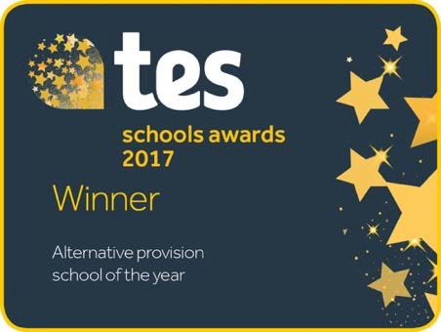


1 Monteagle Way, Hackney E5 8PH www.theboxingacademy.co.uk

Introduction

The Governors of the Boxing Academy are seeking to recruit a Learning Coach / Higher Level Teaching Assistant. This is a significant opportunity for an ambitious candidate to help shape the future of one of the UK’s most successful Alternative Provision schools. The academy provides an alternative pathway for children who have failed in (and been failed by) mainstream education, operating with the spirit of a boxing gym. For any candidate, aligning with this vision and wanting to work to improve the life chances of vulnerable and disadvantaged students is vital.
The Boxing Academy converted in May 2017 to become an Alternative Provision Free School. Since then, it has delivered on its mission of delivering high quality education and development to the most hard-to-reach young people, realised through the discipline and ethos of boxing. The Academy has gained a local and national reputation for excellence by consistently achieving some of the best outcomes of any AP in the country.

In 2017, in recognition of these achievements, the Boxing Academy was named the Tes AP school of year. In March 2020, following its most recent OFSTED inspection, the school was graded ‘Outstanding’.

Diversity

The Boxing Academy is passionate about diversity and recognise that as individuals we all bring something unique to the role regardless of age, gender, race, beliefs or disabilities which is why we treat all our people equally, without compromise. We are committed to ensuring that the recruitment and selection of staff is conducted in a manner that promotes equality of opportunity.

The Boxing Academy is committed to safeguarding children and successful candidates will be subject to an Enhanced DBS check. Our commitment to safeguarding is underpinned by robust processes and checks which all applicants must undergo.

Background of the Boxing Academy

The Boxing Academy was established as a charity in 2007. The Academy addresses a need within the current education system: that the most vulnerable and challenging students do not receive the level of support that they require in mainstream settings. It is our experience that these children then become disengaged causing a cycle of exclusion, failure and low self-esteem which often results in permanent exclusion and has profoundly damaging outcomes in the short- and long-term for the pupils, their schools, their families and the wider community. We reverse this cycle by helping the pupils address their issues and giving them the skills they need to succeed in education and build a productive and happy adult life.

Our Students

The lives of most of the children at the Boxing Academy are often chaotic with no consistent adult presence at home. The experience of these children in education has been profoundly negative and they have low self-esteem and poor confidence. As a result, they can become rude, disruptive and unable to comply with any sort of instruction in a school environment. It has been our experience that for the young people referred to the Boxing Academy, the purpose of education is a mystery; indeed, to some the education system seems to be an elaborate punishment. Our unique approach uses an intensive mentoring system within a framework of small class sizes, high-quality teaching, personal learning support and daily exercise in boxing training to help even

the most difficult-to-reach children to re-engage with their education. All our staff receive training in trauma and attachment awareness, which is employed alongside their key skills of emotional intelligence and compassion.

Why Boxing?

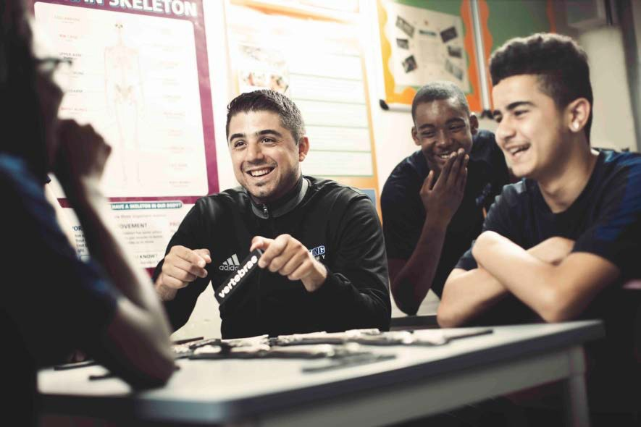
Boxing benefits our students by getting them fit, teaching them teamwork, anger management and discipline, and improving their confidence and concentration. This school is not, however, aiming to produce competitive boxers, in fact many of the students have no interest in Boxing. The value is in the relationships that grow in the gym. We employ boxing coaches in this role because young people instinctively look up to and respect the strong role models within the boxing gym who
present a positive image of respect for others, discipline, responsibility, a work ethic and good manners.

The boxing coaches support their students in the gym and the academic classes which allows the academic teachers to teach without interruption. Our approach to boxing training offers pupils the opportunity to expend their energy in a purposeful manner, to channel their aggression and to learn teamwork, discipline and the acceptance of authority. The support and encouragement they receive improves their self-esteem and confidence, while creating a positive cycle of achievement. Our students are interesting, challenging, lively, bright and funny: attributes that contribute to the unique atmosphere found in the classrooms and the boxing ring.

Curriculum

We currently offer a core curriculum of six GCSE or equivalent subjects including maths, English, Science, Art, RE and PE. The Academy also offers the capacity to sit exams in students’ community language if appropriate. Curriculum delivery is interspersed with boxing sessions, and SMSC, PHSE and British Values. We also offer careers advice, and free to participant trips such as residential outward bounds holidays and an annual ski trip to the Alps.

The curriculum at the Boxing Academy is constantly reviewed and assessed for impact so that we can be sure it meets the needs of our cohort and their ever-changing circumstances.

“The curriculum is designed to prepare pupils for life in modern Britain. Staff quickly get to know each pupil, so that they can provide individualised support. They model the personal characteristics and traits needed to be a successful adult. They listen carefully to pupils’ concerns and interests... Staff ensure that every pupil goes on to suitable education and training when they leave. Pupils follow courses leading to GCSE qualifications. These have been deliberately chosen to give pupils a concrete starting point for future study. Teachers quickly assess pupils’ academic needs. They know that many have gaps in their learning. Some have special educational needs and/or disabilities (SEND). The needs of these pupils are met.” - OfSTED 2020

JOB DESCRIPTION

JOB TITLE: Learning Coach / HLTA

ACCOUNTABLE TO: Senco and SLT

SALARY : £23,366 (BA scale 18, FTE £31,155)

HOURS: 8.30 – 4.30 daily, term time only (option for part time)

JOB PURPOSE

• To complement and support the school by the teaching of 1:1 or whole classes, whilst
progressing children in their learning.
- To contribute to the development of other support staff to ensure that high standards of support for children are consistently maintained.
- To take a lead role in supporting a specific aspect of inclusion such as assessing children with SEN or acting as a Learning Mentor to children who need additional support.
- Reporting to the SENDCo, creating a ‘joined up’ approach to the support of pupils with a variety of needs including learning, behavioural, communication, social difficulties and medical needs.
- Post holders will support the school to fulfil its responsibilities under the SEN Code of Practice.

Main Responsibilities

- Implement planned learning activities/teaching programmes as agreed with the Senco and teacher adjusting activities according to pupils’ responses as appropriate.
- Understand specific learning needs and styles and provide differentiated support to pupils individually and within a group.
- Establish positive relationships with pupils, implementing strategies to support them in their learning and following up and assessing the impact of this support.
- With teachers, evaluate pupils’ progress through a range of assessment activities relating to attainment and progress.
- To contribute to assessments of children, as directed by the class teacher/Senco, and provide reports, evaluations and other information to assist in the provision of appropriate support for specific children.
- Support the role of parents in pupils’ learning and contribute to meetings with parents to provide constructive feedback on student progress, achievement and behaviour, maintaining sensitivity and confidentiality at all times.
- To support and guide other support staff in the classroom and contribute to training for other teaching assistants.

Expectations of all members of the Boxing Academy staff

- Act with professional integrity at all times.
- Consistently demonstrate the high standards expected in the school.
- Act with honesty and transparency with regard to your work.
- Adhere to school policies and procedures at all times.

Professional Standards

- Treat all members of the community, colleagues and pupils, with respect and consideration.

- Treat all pupils fairly, consistently and without prejudice.
- Set a good example to pupils in terms of appropriate dress, standards of punctuality and attendance.
- Read and adhere to the various policies of the school as expressed in the Staff Handbook and Policies.

Health & Safety

- Promote and comply with the school’s policies on Equal Opportunities and Health and Safety both in the delivery of services and the treatment of others.

Safeguarding

The Boxing Academy is committed to safeguarding and promoting the welfare of children and young people and all staff must ensure that the highest priority is given to following the guidance and regulations to safeguard children and young people. All staff are to have due regard for safeguarding and promoting the welfare of children and young people and to follow our child protection procedures. Any safeguarding or child protection issues must be acted upon immediately by informing the Designated Safeguarding Lead.

This job description is additional to the basic duties outlined in contracts and reflects the policies agreed by the Governing Body. The duties, responsibilities and accountabilities highlighted in this job description are indicative and may vary over time. This job description will be reviewed regularly and is an integral part of the appraisal and line management process.

Person Specification

Qualifications | Essential | Desirable
5+ GCSE’s, including English and Maths | x
Knowledge and Skills
Working knowledge of IT packages including Microsoft Word, Excel and Powerpoint | x
Excellent interpersonal skills with the ability to interact effectively and professionally with young people, colleagues and parents | x
Good literacy, numeracy and ICT skills | x
Excellent administrative and organisational skills | x
Ability to work within the academy policies, procedures and expectations | x
Ability to prioritise workloads and work to given deadlines | x
Excellent accuracy and a meticulous attention to detail | x
Ability to work in an organised and methodical manner | x
Ability to work as an effective team member | x
Ability to be remain calm and effective in the face of difficult situations and pressure | x
Ability to convey straightforward information, orally and in writing to colleagues, students and parents | x
Experience
Experience of working within an educational environment or with young people | x
Experience of working in a busy environment and the ability to respond positively to high work demands and at times, extreme pressure | x
Experience of handling confidential information appropriately | x
Experience of undertaking a range of clerical and administrative duties, including data input and retrieval | x
Experience with SEN and other aspects of vulnerability in young people. | x
Personal Qualities & Attributes
Proven tact and diplomacy when dealing with adults and young people. | x
Commitment to following academy expectations with regard to professional behaviour | x
Reliable honest and trustworthy | x
Excellent telephone manner | x
Understanding of the benefits and ethos of Boxing |  | x

