
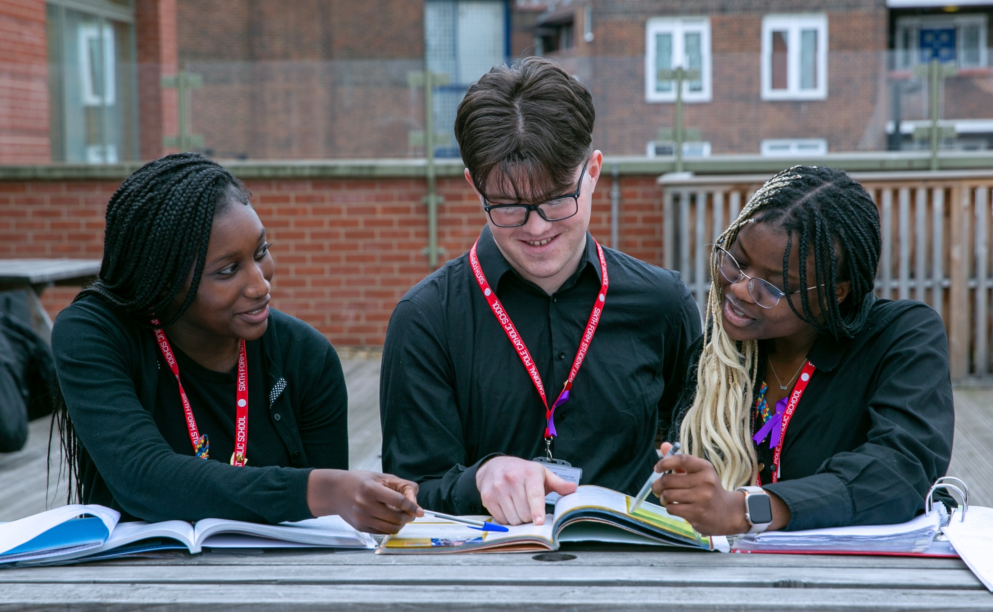

Teaching Assistant

Salary: Scale 4 - £31,980-£33,384 (£28,814-£30,079 pro rata, term time only, 35 hours per week, 8:30-4pm)

Required for: ASAP for the right candidate

Application Closing Date: 30/09/2025

Interview Date: TBC

Please note that Cardinal Pole reserves the right to interview and appoint prior to the closing date.

Why Work at Cardinal Pole?
Firstly, thank you for taking the time to consider applying for the post of Teaching Assistant.
Our school is built on strong foundations of discipline and moral purpose. We offer a lively, dynamic and highly successful environment in which to achieve. We are also a faith community, providing an inclusive and enriching education which cares deeply about the wellbeing and development of our children and our community.
Cardinal Pole School is an inclusive school where all members of the school community are of equal worth and each have the opportunity to be the best that they can be. We are a community of service guiding young people on a path to opportunity, aspiration and reward, founded on Catholic values.

We seek to ensure that everyone is treated with dignity and respect. We also make sure all our students pursue a rich programme of study at all key stages appropriate for their age and ability, ensuring that there is no narrowing of the curriculum. These aims, coupled with high expectations for everyone, has resulted in remarkable success for our students.
We very much welcome applications from all faiths and backgrounds and value the unique experience that every individual can bring to our school and look forward to receiving your application.
Professional Development: We can offer you professional development to begin or advance your career. You will be part of a school that is established in developing practitioners and nurturing future leaders. The opportunities for progression at Cardinal Pole are significant. We offer a range of CPD, including multiple Middle Leadership pathways in addition to supporting preparation for Senior Leadership via MA study, NPQSL and SLT secondment opportunities. There is no doubt that these opportunities will help you achieve your own career ambitions rapidly.

Benefits
- Two-week October half term break.
- You will be joining an AWARD-WINNING National School of the Year 2024 & TWICE TES Secondary School of the Year nominated school.
- Free staff access to a modern and high-quality gym which was fully refurbished in September 2023.
- An incredible team of staff who are highly skilled, dynamic and passionate about securing the very best outcomes for the community we serve.
- Excellent CPD opportunities at all levels including part-funded MA study (T&Cs apply).
- Opportunities for progression.
- Sophisticated modern school building set in the heart of vibrant Hackney
- A proactive and thriving staff well-being group with regular staff socials, coffee mornings and opportunities for cross departmental interaction
- Free Breakfast Club every day for staff and students
- Free Bike servicing for staff
- Travel Loans. Interest free loans to assist staff in meeting travel costs (T&Cs apply)
- Teachers’ Pension Scheme or Local Government Pension Scheme which includes 3 x salary life assurance cover whilst you remain in service.
- Employee Assistance Programme

Job Title: Teaching Assistant
Reporting to: Head of SEN
Grade: Scale 4 - £31,980-£33,384 (£28,814-£30,079 pro rata, term time only, 35 hours per week, 8:30-4pm)
Hours: 35 hours per week, Term Time only

Purpose of the Post
To work under the direct instruction of teaching / senior staff, usually in the classroom with the teacher, to support access to learning for pupils and provide general support to the teacher in the management of pupils in the classroom.
To supervise whole classes during the short-term absence of teachers within a department or faculty.

Main Duties and Responsibilities
Support for Pupils:
- Supervise and provide particular support for pupils, including those with special needs, ensuring their safety and access to learning activities.
- Assist with the development and implementation of Individual Education/Behaviour Plans and Personal Care programmes.
- Establish constructive relationships with pupils and interact with them according to individual needs.
- Promote the inclusion and acceptance of all pupils.
- Encourage pupils to interact with others and engage in activities led by the teacher.
- Set challenging and demanding expectations and promote self-esteem and independence.
- Provide feedback to pupils in relation to progress and achievement under guidance of the teacher.
- Deliver pastoral and learning support.
- To deal with minor incidents and the health and hygiene of the children and where necessary, escort them home.
- To read with individual children and groups and complete reading records as directed by the class teacher.
- Under the direction of teacher, to work with small groups of children and to take responsibility for their learning.

Support for the Teacher:
- Create and maintain a purposeful, orderly and supportive environment, in accordance with lesson plans and assist with the display of pupils’ work.
- Use strategies, in liaison with the teacher, to support pupils to achieve learning goals.
- Assist with the planning of learning activities.
- Monitor pupils’ responses to learning activities and accurately record achievement/progress as directed.
- Provide detailed and regular feedback to teachers on pupils’ achievement, progress, problems etc.
- Promote good pupil behaviour, dealing promptly with conflict and incidents in line with established policy and encourage pupils to take responsibility for their own behaviour.
- To establish and maintain constructive relationships with parents/carers by:

  - supporting their role in pupils’ learning;
  - providing constructive feedback on pupils’ progress and achievements;
  - facilitating their support for their child’s attendance;
  - support home to school/community links.

- Administer routine tests and invigilate exams and undertake routine marking of pupils’ work.
- Provide clerical/admin. support e.g. photocopying, typing, filing, money, administer coursework etc.
- To work within an agreed system of supervision with small groups of children and to take responsibility for their learning.
- To work in partnership with the teacher to support the school induction programme. This may include contributing to parents evening as appropriate.

Support for pupils in the absence of the teacher:
- To supervise pupils whose teacher is absent.
- To ensure that pupils whose teachers are absent are given cover work and resources, as instructed by the Head of Department / Faculty.
- To instruct pupils regarding work left by their teacher or Head of Department / Faculty.
- To supervise pupils in the Pupil Inclusion Room and ensure that pupils referred to the Pupil Inclusion Room are correctly referred and provided with work, as instructed by their Teacher and / or Head of Department.
- To create a calm and purposeful environment in which students can complete work set by the classroom teacher or Head of Department / Faculty and engender high expectations.
- To provide pupils with the necessary resources for their learning.
- To register and record student attendance.
- To enable orderly entrance and exit of study areas.
- To liaise with teachers, Head of Department / Faculty and the cover manager about cover work and to collect any completed work after the lesson and follow up any issues .

Support for the Curriculum:
- Undertake structured and agreed learning activities/teaching programmes, adjusting activities according to pupil responses.
- Undertake programmes linked to local and national learning strategies e.g. literacy, numeracy, KS3, record achievement and progress and feed back to the teacher.
- Support the use of ICT in learning activities and develop pupils’ confidence, competence and independence in its use.
- Prepare, maintain and use equipment/resources required to meet the lesson plans/relevant learning activity and assist pupils in their use.

Support for the School:

To successfully complete the school’s induction programme and provide a level of support which is commensurate with the school’s expectation and standards

- Be aware of and comply with policies and procedures relating to child protection, health, safety and security, confidentiality and data protection, reporting all concerns to an appropriate person.
- Be aware of and support difference and ensure all pupils have equal access to opportunities to learn and develop.
- Contribute to the overall ethos/work/aims of the school.
- Appreciate and support the role of other professionals.
- Attend and participate in relevant meetings as required.
- Participate in training and other learning activities and performance development as required.
- Assist with the supervision of pupils out of lesson times, including before and after school and at lunchtime.
- Accompany teaching staff and pupils on visits, trips and out of school activities as required and take responsibility for a group under the supervision of the teacher. To assist in the general care of the school environment by undertaking tidying of general areas.
- To promote equal opportunities at all times.
- Establish constructive relationships and communicate with other agencies/professionals, in liaison with the teacher, to support achievement and progress of pupils.
- Recognise own strengths and areas of specialist expertise and use these to lead, advise and support others.
- To undertake additional or other duties as may be appropriate to achieve the objectives of the post and as directed and deemed appropriate by the Line Manager.

This is a description of the main duties and responsibilities of the post at the date of production. The duties may change over time as requirements and circumstances change. The person in the post may also have to carry out other duties as may be necessary from time to time.

Safeguarding and Promoting the Welfare of Children and Young People:
Cardinal Pole School is committed to safeguarding and promoting the welfare of children and young people and expects all staff and volunteers to share this commitment.

Key Organisational Objectives:

The Postholder will contribute to the school’s objectives in service delivery by:

- sharing the schools commitment to safeguard and promote the welfare of children and young people
- enactment of Health and Safety requirements and initiatives as directed
- ensuring compliance with Data Protection legislation
- at all times operating within the school’s Equal Opportunities framework
- commitment and contribution to improving standards for pupils as appropriate
- promoting customer care and quality in line with the school policy
- contributing to the maintenance of a caring and stimulating environment for pupils

Conditions of Service:
Governed by the National Agreement on Pay and Conditions of Service, supplemented by local conditions as agreed by the governors

Special Conditions of service:
Because of the nature of the post, candidates are not entitled to withhold information regarding convictions by virtue of the Rehabilitation of Offenders Act 1974 (Exemptions) Order 1975 as amended. Candidates are required to give details of any convictions on their application form and are expected to disclose such information at the appointment interview. In addition, as this post allows substantial access to children, candidates are required to comply with departmental procedures in relation to Police checks. If candidates are successful in their application prior to taking up post, they will be required to give written permission to the Department to ascertain details from the Metropolitan Police regarding any convictions against them and, as appropriate the nature of such convictions. A full enhanced DBS check will be undertaken prior to commencement

Equal Opportunities:
The post holder will be expected to carry out all duties in the context of and in compliance with the School’s Equal Opportunities Policies.

Person Specification:
 | Essential | Desirable
Essential Knowledge & Qualifications
Training in the relevant learning strategies e.g. literacy
First aid training as appropriate
Understanding of relevant policies and codes of practice and awareness of relevant legislation
General understanding of national curriculum
Basic understanding of child development and learning

Experience
Experience of using Microsoft Office Suite
Experience of using Email/Internet
Experience of or working with or caring for children of 11 – 19 age group
Skills

Personal
Good numeracy and literacy skills
Effective use of ICT to support learning
Use of other equipment technology – computer, video photocopier
Ability to self-evaluate learning needs and actively seek learning opportunities
Ability to relate well to children and adults
To work constructively as part of a team, understanding classroom roles and responsibilities and your own position within these
Participate in development and training opportunities

Relations
Have good interpersonal skills and be able to communicate effectively
Ability to develop good relations with staff, pupils and governors

