Harrington Hill Primary School
Teaching Support Staff Application Pack

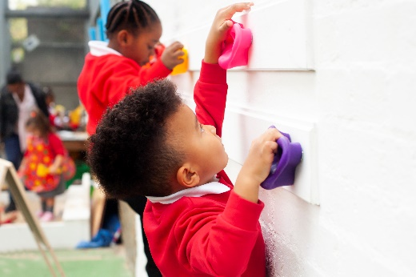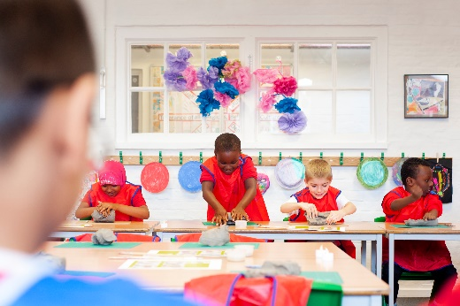

Recruiting for: Teaching Assistant
Fixed term 12 months
Closing date for applications: Monday 1st June 2026 at 12pm
Interview Date: Wednesday 10th June 2026



CONTENTS
- Welcome!
- What are we looking for?
- What do we offer?
- How to apply
- Job description & person specification
- Gallery
Dear Applicant,

Thank you for your interest in applying for a position as a Teaching Assistant (TA) at Harrington Hill. If you would like to learn more about the school, we would be delighted to offer you a tour of the school or answer any questions you may have. Our school website offers a wealth of information about the school too.

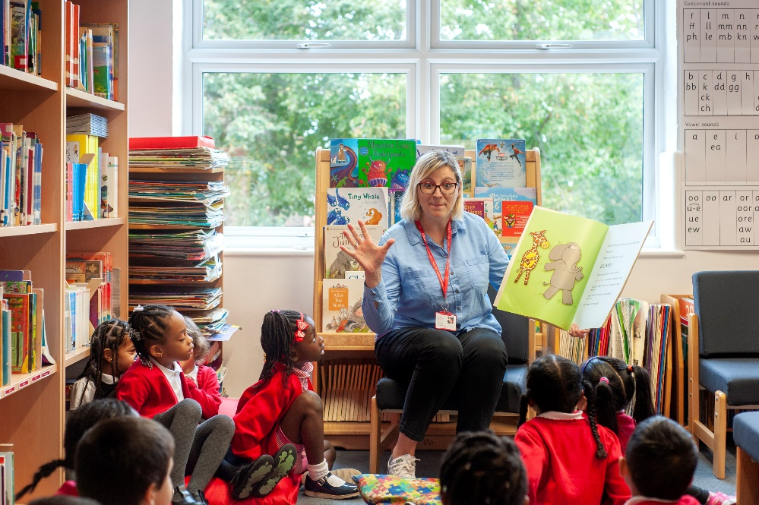
Harrington Hill is based in the vibrant and diverse community of Hackney, East London and has excellent transport links into and out of Central London. At Harrington Hill, we understand that children learn best when they feel happy, safe and valued at school. We provide a rich and exciting curriculum to develop their confidence and enthusiasm for lifelong learning. We are absolutely committed to ensuring every child achieves well and develops high aspirations for their futures. Harrington Hill recently opened an ARP for autistic pupils. We pride ourselves on our inclusive high-quality education for all pupils. We are looking for a teaching assistant to support pupils primarily within the mainstream classrooms, however there may also be opportunities to work with pupils accessing the ARP.

Harrington Hill had its Ofsted inspection in November 2023. We were pleased that Ofsted agreed with our outstanding judgements for EYFS, Behaviour & Attitudes, Personal Development and that the quality of education offered to all children is of a high standard. Please see the link to the full report:
https://reports.ofsted.gov.uk/provider/21/100256

We are looking to recruit support staff who are keen to develop their career and have the energy and passion to make a difference to the lives of our children. We are committed to supporting staff at every stage of their careers and can provide bespoke training and the support of a dedicated, passionate and encouraging staff team. We are particularly interested in hearing from candidates with experience supporting pupils in upper key stage 2.

Rebecca Kennedy
Headteacher

WHY WORK WITH US?
.

- We are a warm and welcoming school with an enthusiastic, dynamic and talented staff team

- We offer excellent CPD and career development

- We have wonderful children who strive to achieve their best

- We offer a renovated building with large classrooms, a sensory room for children with SEND and on-site Forest School facilities

- We have a consultative, highly supportive Leadership Team and Governing Body

- Staff and children’s wellbeing is very important to us: we are a happy school community!

WE ARE LOOKING FOR SUPPORT STAFF WHO:

- are hard workers with a passion for their job

- are committed to providing an aspirational learning environment to achieve excellent progress for all children

- have a professional outlook, thrive on challenge and strive for excellence

- Enjoy working with others and being part of a team

Our school is committed to safeguarding and promoting the welfare of children and young people and expects all staff and volunteers to share this commitment. We welcome applications from all sections of the community, regardless of gender, race, religion, disability, sexual orientation or age.



JOB DESCRIPTION  Full time, Fixed Term, starting September 2026.  Grade: TA - Scale 4 Spine 7-10 (36hrs, pro rata £27,754 – £28,972  Purpose of the post:  To enable all children including children with SEND to flourish in their learning. To enable children to engage in learning under the direction of the Deputy Headteacher and class teachers.  Essential Qualifications  - NVQ 2 for Teaching Assistants or equivalent qualifications or experience  - Strong numeracy/literacy skills  - Experience  - Some experience of teaching in a multicultural inner-city environment  - Sound understanding of child development and learning  Main Duties and Responsibilities  Support for Pupils:  - To enhance children’s learning through participating in rich meaningful learning experiences.  - Assist with the development and implementation of support plans  - Establish constructive relationships with pupils and interact with them according to individual needs.  - Promote the inclusion and acceptance of all pupils.  - Provide 1:1 or small group support to pupils working within the mainstream classrooms or within the ARP.  - Encourage pupils to interact with others and engage in learning experiences  - Set challenging and demanding expectations and promote self-esteem and independence.  - Provide feedback to pupils in relation to progress and achievement under guidance of the teacher.  - Deliver pastoral and learning support.  - To deal with minor incidents and the health and hygiene of the children.  - Under the direction of DHT/class teachers, to work with groups of or individual children and to take responsibility for their learning.  - Promote good pupil behaviour, dealing promptly with conflict and incidents in line with established policy and encourage pupils to take responsibility for their own behaviour.  - To establish and maintain constructive relationships with parents/carers by: supporting their role in pupils’ learning and providing constructive feedback on pupils’ progress and achievements. | Support for the Curriculum:  - Undertake meaningful and agreed learning experiences, adjusting activities according to pupil responses.  - Support the use of ICT in learning activities and develop pupils’ competence and independence in its use.  - Prepare, maintain and use equipment/resources required to meet the lesson plans/relevant learning activity and assist pupils in their use.  Support for the School:  - Be aware of and comply with policies and procedures relating to child protection, health, safety and security, confidentiality and data protection, reporting all concerns to an appropriate person.  - Be aware of and support difference and ensure all pupils have equal access to opportunities to learn and develop.  - Contribute to the overall ethos/work/aims of the school.  - Appreciate and support the role of other professionals.  - Attend and participate in relevant meetings as required.  - Participate in training and other learning activities and performance development as required.  - Accompany teaching staff and pupils on visits, trips and out of school activities as required and take responsibility for a group under the supervision of the teacher.  - To assist in the general care of the school environment by undertaking tidying of general areas  - To promote equal opportunities at all times.  - Establish constructive relationships and communicate with other agencies/professionals, in liaison with the teacher, to support achievement and progress of pupils.  - Recognise own strengths and areas of specialist expertise and use these to lead, advise and support others.  To undertake additional or other duties as may be appropriate to achieve the objectives of the post and as directed and deemed appropriate by the Line Manager.  Person Specification  - Ability to relate well to children and adults.  - Work constructively as part of a team.  - Proactive approach to identifying where to allocate support within a classroom.  - Ability to self-evaluate learning needs and actively seek learning opportunities.  - Display commitment to protection and safeguarding of children and young people.  - A willingness to be flexible and responsive to the schools’ needs.

HOW TO APPLY
- Read the job description and person specification carefully.

- Complete the application form either electronically or print it off and hand write it.

- Ensure your supporting statement relates to the competencies outlined in the person specification.

- Email your competed application to Mrs Alex DeDominicis at
admin@harringtonhill.hackney.sch.uk
or send by post:
Harrington Hill Primary School Mount Pleasant Lane
London E5 9JG

- Please make sure that your application form indicates the name & address of the school where you have most recently taught and the age group that you currently working (if applicable).

Closing date: Monday 1st June at 12pm
Interview Date: Wednesday 10th June 2026

Our school is committed to safeguarding and promoting the welfare of children and young people and expects all staff and volunteers to share this commitment.

Successful candidates will be required to complete an enhanced DBS disclosure.

We welcome applications from all sections of the community, regardless of gender, race, religion, disability, sexual orientation or age.

Should you have any queries or would like to arrange to visit our school please contact Mrs Alex DeDominicis on: 0208 806 7275 or email: admin@harringtonhill.hackney.sch.uk

We look forward to receiving your application!

