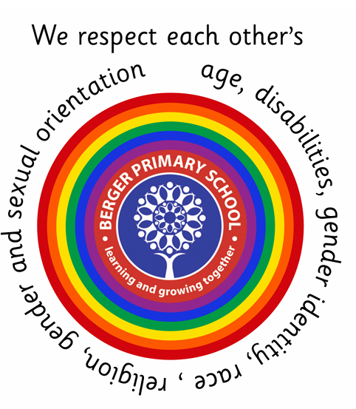
Keyworker - Berger Primary School
Reference: Keyworker
Vacancies: 1
Salary: Scale 5, Point 12 (Pro rata) actual salary £27,965.99 - £29,866.98
Contract: Fixed term until July 2027 with the possibility of being extended
Details: Hours: 33.75hrs per week, Monday- Friday 8.30am - 4.15pm
Keyworker/Nursery Practitioner (2–3 Year Old Room) – Level 3 Qualified
We are excited to offer a fantastic opportunity for an experienced Level 3 qualified Nursery Practitioner to join our growing early years team. This role is part of the expansion of our nursery within Berger Primary School's setting , making it an ideal time to join a supportive
and forward-thinking environment.
As we expand our provision for 2–3 year olds, we are looking for a passionate practitioner who is committed to high-quality early years education and care.
Key Responsibilities
-Provide a safe, caring, and stimulating environment for children aged 2–3 years.
-Plan and deliver engaging activities in line with the EYFS framework.
-Support children’s learning, development, and wellbeing.
-Build positive relationships with children, parents, and colleagues.
-Contribute to observations, assessments, and planning.
-Maintain high standards of safeguarding, health, and safety.

Requirements
-Full and relevant Level 3 Early Years qualification .
-Pediatric First Aid Qualification is desirable but not essential for the right candidate.
-Previous experience working with children aged 2–3 years.

